DATA ON BIRDS ALONG PROPOSED ROUTES 8/9 OF THE EAST-WEST RAIL LINE

Introduction

This paper comprises an assessment of the birdlife along routes 8/9 of the proposed East-West Rail line through the Parish of Renhold. It contains the following material:

- Definition of the area assessed.

- Description of the habitats affected.

- Data sources.

- Breeding birds.

- Wintering birds.

- The impact of the railway.

- Conclusions.

- The material was complied by Tony Ploszajski, a former Records and Research Officer for the Bedfordshire Bird Club, who has lived in Renhold since 2010 and has more than 30-years’ birdwatching experience in the county and beyond.

General context

- The ‘Bedford Borough Landscape Character Assessment’ (2013) ‘provides a comprehensive landscape evidence base to help underpin planning and management decisions in the Borough’. It includes a section on the ‘Renhold Clay Farmland’ which covers Renhold parish. The headline findings are as follows:

- Landscape Strategy: ‘To enhance the elements of the landscape that are in declining condition or detract from the rural character, in particular the hedgerows and hedgerow field trees and the north-east edge of Bedford. At the same time conserving and enhancing the open rural landscape with its scattered small-scale settlements and farmsteads and historic earthworks, ancient woodlands and grasslands of high biodiversity value. Seek to create landscape connections into adjacent green infrastructure opportunity areas and proposals such as the Bedford River Valley Park associated with the adjacent Ouse Valley.’

- Landscape management: Measures include:

- ‘Conserve the character of the rural roads and limit urbanising influences and ensure that traffic management measures are sympathetic to the rural character’.

- ‘Enhance the hedgerows consistent management and resist development that will result in further loss/fragmentation of hedgerows or hedgerow trees’.

- ‘Conserve tree-lined brooks and associated riparian features’.

- Development guidelines: These are:

- ‘Conserve the scattered farmsteads and historic villages with their pattern of dispersed ‘Ends’ and the views to the stone churches’.

- ‘Retain the individual settlements avoiding merging these through linear development particularly immediately to the north of Bedford for instance along the roads between the various ‘ends’ of Renhold’.

- ‘Consider planting new woodlands to screen the urban boundary of north east Bedford in views from the open countryside to the north. Where possible this should also create landscape links into adjacent green infrastructure initiatives and mitigation projects such as the Bedford River Valley Park’.

The area

The area assessed for the survey comprises an area 50m either side of the line of the proposed routes 8/9, indicated on the map below.

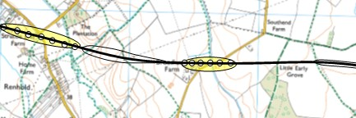

The habitats

Three main habitats are affected:

- The Ravensden Brook and its immediate surrounds.

- Farmland comprising arable and sheep fields, with mature hedgerows.

- Ancient woodland in Little Early Grove and Great Early Grove.

Sources of data

- Two main sources of data were assessed:

- Bird sightings compiled on a year-round basis by Tony Ploszajski in the period 2010-2021.

- A breeding bird survey conducted by Tony Ploszajski in April-May 2021.

- The ‘status’ of the species noted is based upon their conservation importance as defined by the ‘Birds of Conservation Concern’ classifications recognised by Natural England.

- ‘Red List’ species: These are defined as:

- The species is globally threatened.

- Historical population decline in UK during 1800-1995.

- Severe (at least 50%) decline in UK breeding population over last 25 years.

- Severe (at least 50%) contraction of UK breeding range over last 25 years.

- ‘Amber List’ species: These are subject to at least one of the following:

- Species with unfavourable conservation status in Europe.

- Historical population decline during 1800–1995 but recovering; population size has more than doubled over last 25 years.

- Moderate (25-50%) decline in UK breeding population over last 25 years.

- Moderate (25-50%) contraction of UK breeding range over last 25 years.

- Moderate (25-50%) decline in UK non-breeding population over last 25 years.

- Rare breeder, 1-300 breeding pairs in UK.

- Rare non-breeders, less than 900 individuals.

- Localised, at least 50% of UK breeding or non-breeding population in ten or fewer sites.

- Internationally important, at least 20% of European breeding or non-breeding population in UK.

- ‘Green List’ species: Species on the green list are the least critical group, that occur regularly in the UK but do not qualify under any or the above criteria.

Breeding birds

Ravensden Brook and its immediate surrounds: The following species are dependent upon the brook and its banks to nest and feed:

Species | Pairs | Status
Kingfisher | 2 | Amber
Grey Wagtail | 1 | Red

Farmland: The following species are dependent upon the fields and hedgerows to nest and feed:

Species | Pairs | Status
Corn Bunting | 3 | Red
Skylark | 14 | Red
Yellowhammer | 4 | Red
Linnet | 6 | Red
Barn Owl | 1 | Green
House Sparrow | 12 | Red
Bullfinch | 4 | Amber
Kestrel | 1 | Amber
Lapwing | 2 | Red

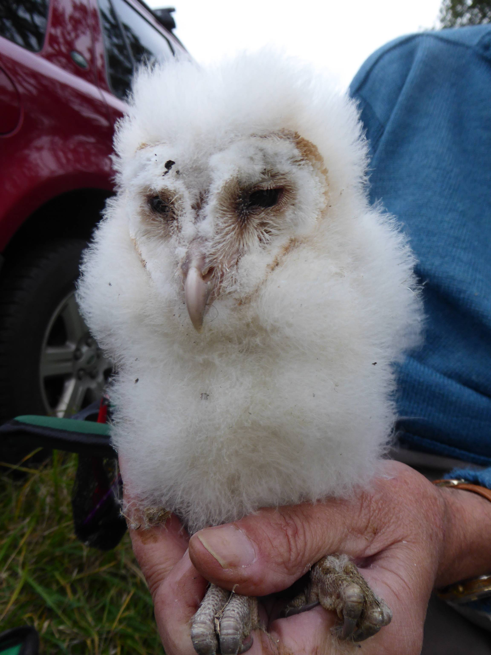

Young Barn Owl from the nest box by Great Early Grove

Ancient woodland: The following species are dependent upon the woodland to nest and feed:

Species | Pairs | Status
Marsh Tit | 1 | Red
Great Spotted Woodpecker | 3 | Green
Nuthatch | 3 | Green
Treecreeper | 4 | Green
Great Tit | 6 | Green
Blue Tit | 9 | Green
Red Kite | 1 | Green
Buzzard | 1 | Green
Dunnock | 5 | Amber
Tawny Owl | 1 | Amber
Goldcrest | 2 | Green
Chaffinch | 2 | Green
Greenfinch | 2 | Green
Stock Dove | 1 | Amber
Wren | 4 | Green
Song Thrush | 3 | Red
Jay | 1 | Green
Carrion Crow | 4 | Green
Blackbird | 6 | Green

Wintering birds

Ravensden Brook and its immediate surrounds: The following species are dependent upon the brook and its banks for food and shelter in the winter months:

Species | Maximum Count | Status
Kingfisher | 3 | Amber
Grey Wagtail | 2 | Red
Little Egret | 2 | Green
Stonechat | 2 | Green
Meadow Pipit | 35 | Green
Mistle Thrush | 7 | Green
Fieldfare | 40 | Red
Redwing | 38 | Red
Pied Wagtail | 8 | Green
Sparrowhawk | 2 | Green
Kestrel | 2 | Amber
Heron | 2 | Green

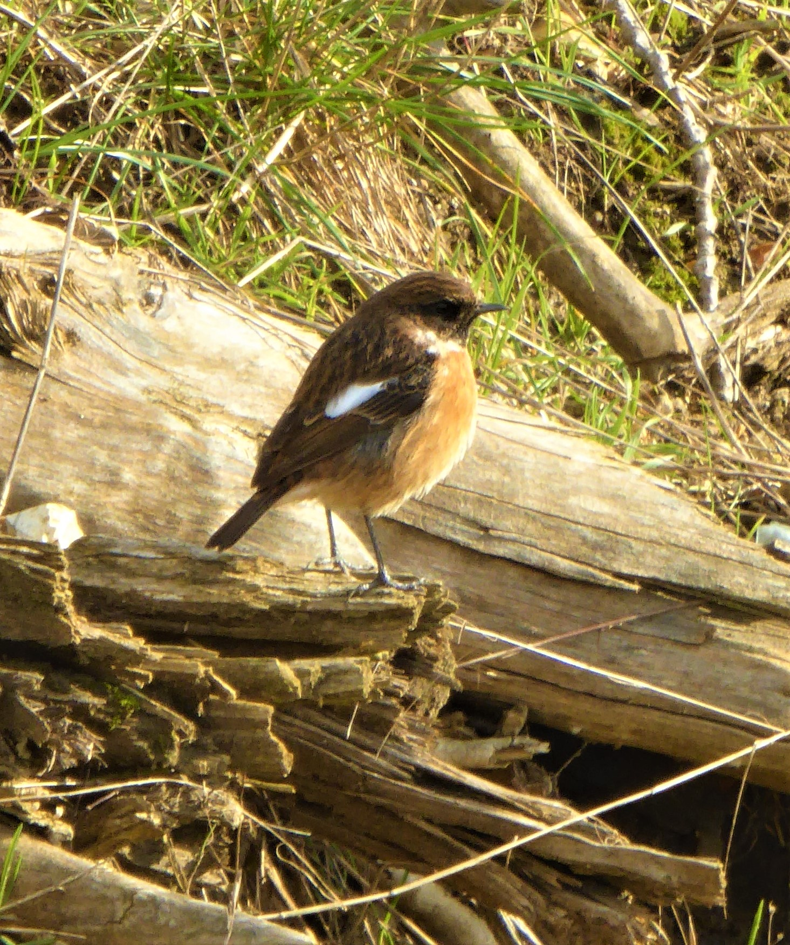

Wintering Stonechat by Ravensden Brook

Farmland: The following species are dependent upon the fields and hedgerows for food and shelter in the winter months:

Species | Maximum Count | Status
Corn Bunting | 6 | Red
Skylark | 24 | Red
Yellowhammer | 23 | Red
Linnet | 56 | Red
Barn Owl | 6 | Green
House Sparrow | 44 | Red
Bullfinch | 6 | Amber
Kestrel | 3 | Green
Reed Bunting | 5 | Amber
Fieldfare | 51 | Red
Redwing | 32 | Red
Carrion Crow | 39 | Green
Rook | 71 | Green
Jackdaw | 43 | Green

Ancient woodland: The following species are dependent upon the woodland for food and shelter in the winter months:

Species | Maximum Count | Status
Marsh Tit | 3 | Red
Great Spotted Woodpecker | 7 | Green
Nuthatch | 8 | Green
Treecreeper | 6 | Green
Great Tit | 14 | Green
Blue Tit | 21 | Green
Red Kite | 3 | Green
Buzzard | 4 | Green
Dunnock | 12 | Amber
Tawny Owl | 2 | Amber
Goldcrest | 8 | Green
Chaffinch | 13 | Green
Greenfinch | 7 | Green
Stock Dove | 4 | Amber
Wren | 12 | Green
Carrion Crow | 40 | Green
Rook | 3 | Green
Jackdaw | 23 | Green

The impact of the railway

The proposed railway will have the following impact on the bird species and the habitats upon which they depend:

- Habitat degradation: The railway line and its associated viaducts and cuttings will degrade the existing habitat by reducing the available area, segmenting breeding territories and foraging areas.

- Disturbance: The noise and disruption during the construction phase will displace birds from their current breeding and foraging areas into less suitable areas that will be unable to sustain the same numbers. Once the railway is operational, the ongoing noise and activity will continue to disrupt the local birdlife. Species like Barn Owls that largely hunt by sound will be unable to hear their prey and will be unable to survive as a result.

Conclusions

The area along proposed route 8/9 of the East-West Railway through Renhold parish currently sustains important populations of nine ‘Red List’ bird species of conservation concern and a further six ‘Amber List’ species.

The destruction and degradation of habitat would have a severely detrimental effect on the ability of all the species concerned to maintain their current numbers and given the fragile state of their respective populations, it will hasten the demise of birds that are already heavily threatened.

The landscape impact of proposed route 8/9 is totally contrary to the provisions of the ‘Bedford Borough Landscape Character Assessment’ (2013).

